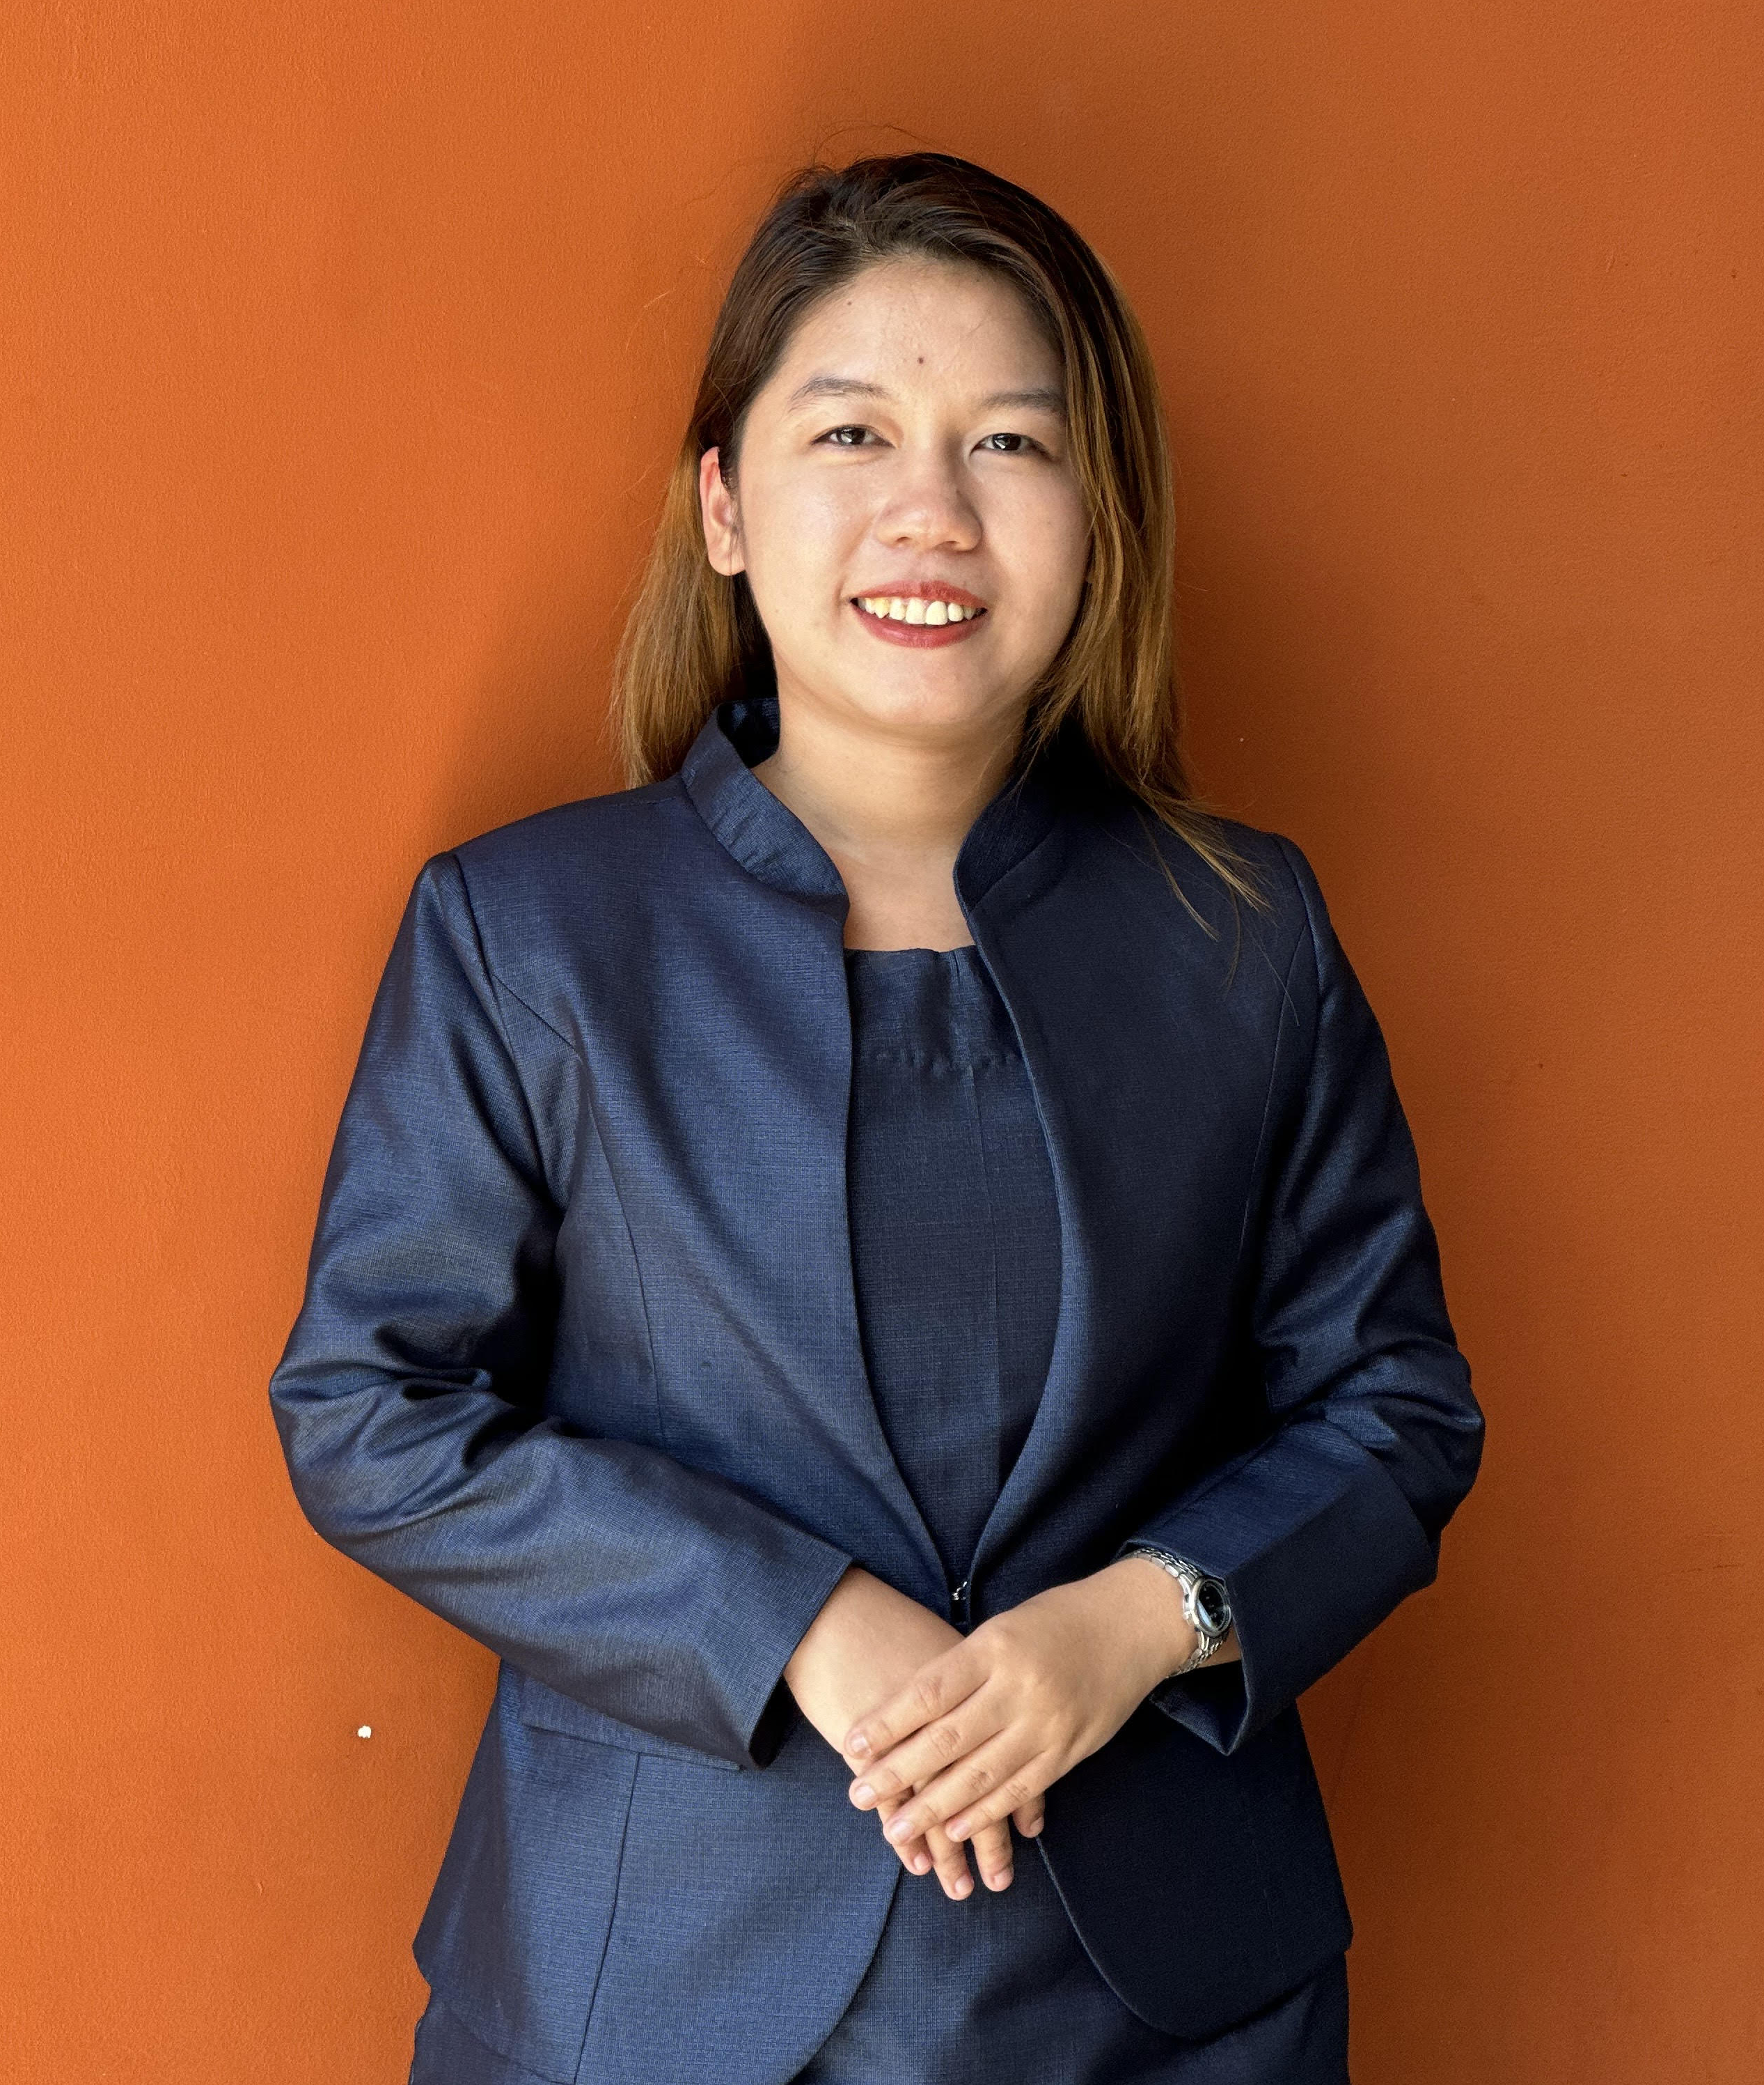
May Yoon Pwint Phyu
📍 Bangkok, Thailand
📞 +66 6 57673844
📧 yoonpwint99@gmail.com
💬 Line ID: mariayoon

Professional Summary
Experienced sales professional with over 6 years of expertise in hotel room and event sales. Proven ability to manage OTA platforms, exceed revenue targets, and build strong client relationships. Recognized with the 'Best of the Year 2018' award at Esperado Lake View Hotel. Skilled in reservations, rate management, and guest service with a strong track record in hospitality sales and coordination.

Work Experience

Sales Executive
Avenue2Gold Co., Ltd | Mar 2025 – Present
- Promote and sell residential and commercial properties, including condos, townhouses.
- Assist clients with property inquiries, site viewings, and investment advice based on market trends.
- Negotiate pricing and close sales deals with clients and developers.
- Maintain client relationships and provide after-sales service for long-term engagement.
- Collaborate with marketing teams to generate leads through social media and property listings.

Reservation & Receptionist
Sweet Hotel, Phuket | Mar 2024 – Aug 2024
- Managed guest reservations via phone, email, and online platforms.
- Handled check-in/out and ensured excellent guest service.
- Processed payments and maintained records using PMS systems.
- Coordinated with internal departments to meet guest needs.

Sales Manager
Inya Lake Hotel, Myanmar | Nov 2023 – Feb 2024
- Led the sales team in achieving revenue goals.
- Negotiated contracts and closed deals with key clients.
- Provided performance insights to senior leadership.
- Built and maintained strong client partnerships.

Assistant Sales Manager
Sunny Paradise Resort | May 2021 – Oct 2023
- Supervised the sales team and supported in achieving monthly targets.
- Managed reservations for individual, group, and corporate clients.
- Negotiated rates and upsold services to boost revenue.
- Responded to inquiries and tailored solutions for clients.
- Generated reports to track sales and booking trends.

Sales Executive (Pre-opening Team)
Yangon Thanlwin Hotel | Dec 2019 – Jun 2020
- Promoted hotel services pre-opening to build brand awareness.
- Conducted sales meetings and presented proposals.
- Coordinated marketing campaigns and client relations.
- Established and managed a growing client portfolio.

Sales Executive
Best Western Chinatown Hotel | Mar 2019 – Dec 2019
- Prospected new clients and grew the customer base.
- Conducted site inspections and managed client visits.
- Prepared proposals and collaborated with the reservations team.

Sales & Marketing Executive
Esperado Lake View Hotel | Mar 2017 – Feb 2019
- Executed marketing campaigns and managed social media.
- Created promotional offers and collaborated with sales.
- Organized marketing events and joint promotions.

Education
- Bachelor of Arts in History, Dagon University | 2015 – 2019
- Diploma in Hospitality & Tourism Management, Star University | 2015 – 2016
- Certified in Sales & Sales Management, MIBA | 2023

Languages
- Burmese (Native)
- English (Fluent)

Hard Skills
- Reservation Systems (OPERA)
- Rate & Channel Management
- Data Entry & Payment Processing
- OTA & Booking Platforms
- Microsoft Office Suite
- Reporting & Analysis

Soft Skills
- Communication & Customer Service
- Time Management & Organization
- Problem-Solving & Attention to Detail
- Adaptability & Interpersonal Skills

References Available on Request

